Many Jobs One Career

Task 1
Get a good job

Task 2
turn that good job into a string of good jobs and build a good career

Your Name _____________________________________________________

How Do You Get a Good Job?
Sharla and Tracey will show you how to:
  - Create a great Network and Reputation
  - Create a great Resume and References
  - Ace Interviews
  - Build Relationships and Experiences

But, How Do People Manage Their Career?
- There are many types of people but we will look at three common career management methods that are frequently adopted.

1 The Summit or Plummet Career Managers
Do “What It Takes” to achieve
Want something different
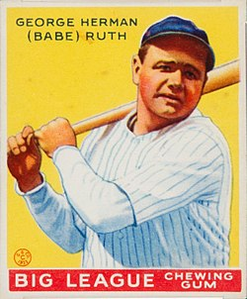
This Photo by Unknown Author is licensed under CC BY-SA
You Know this Stereotype: they say things like “if you make a good sale, don’t celebrate, make another sale.” Or “Success is just working harder” and some of these people have done amazing things, like build companies or fortunes or even win wars.

They also can pay a heavy price for their dedication to “doing what has to be done”. Lost marriages and families, overworked and unhealth lifestyles are common with this crowd. So along with spectacular successes, catastrophic crashes can be found.

I think of Babe Ruth when I think of Summit or Plummet. He was famously aggressive at chasing opportunity. It worked out for him as he often had an over .300 batting average (hit 3 out every 10 times at bat). However, he did pay a price for his uncompromising nature. He had so many drinking, partying and aggressive exploits by the time he retired as a player that no one would hire him as a manager.

2 The Rambling Career Manager

I can’t really think of anyone famous that we would all know who is a Rambler but I have met these folks and I often find myself enjoying their company. These are the people that don’t stay focused on one thing for too long. They may bounce from one job to another for various reasons including:

- they follow other people’s advice and if that does not work out they look for another advisor
- they just want to explore everything and often everywhere, they love change and variety
- do not know what work and training options are open for them and they bounce from job to job looking for something great

Good things can and do happen to these folks but luck has to be a part of the equation. It is not uncommon to find them working hard for someone who underpays them or takes advantage of their better nature. Often these career managers end up very frustrated because they aren’t able to find a way to progress and move forward in their careers, it seems that they get the same kind of deal no matter how many times they change jobs.

3 The Goldilocks Solution

This is the method we suggest people adopt for Career Management. It gives you some of the freedom of the Ramblers and some opportunity to be goal focused like the summit or plummet crowd, but is less likely to lead you into some of the troubles of the other two methods. Basically, it is a system that is trying to play the odds by using strengths of the other two systems but avoiding the weaknesses.
This Photo by Unknown Author is licensed under CC BY-NC-ND

This makes good sense, but some people are not about playing the odds, and they strike off to take great risks of one kind or another, and that can be very successful or catastrophic.

For the rest of us lets look at a way to Ramble around looking for opportunity, but also include enough goal focus to overcome barriers and win out at the end of the day.

notes

See article a Better Way to Plan Your Career

Good Career Managers:
- Identify their Options
- Find ways to achieve what they want
- Create a Plan
- Staying on Track

Identifying your options sounds obvious but it is not often done well. Let’s try a Test: Assuming that most people want Financial Security – write down as many occupations that you can think of that offer it. Write your thoughts here:

Finding Ways is not our normal routine, often we just fall into an opportunity. How do you find out what you have to do to be successful in a field? Where will you find that opportunity?

Does Planning Work? Do Plans Work? These are actually two very different questions and we will look at why one of the answers is “It’s your best chance”.

Once you’re on your way – How do you avoid Burnout, Distraction and other barriers and stay on track?

Section A) Identify Your Options

The Basics:

Identify your Interests, the Values you will not give up, your key Skills or Strengths and your key Traits and then use this knowledge to find occupations that move you along your career path.

Interests Defined
interests are things you like to learn about or spend time on. The key here is the like part – what do you like…

Interest Exercise 1: What are your personal interests?
- think about what you like to spend money and time on
- also think about what you would like to spend time and money on if you had it
- record your ideas in the list below

Interest Exercise 2:
- Brainstorm interesting things with the group
- Identify which of these things are interesting to you and add them to the list below
- If you need help turn to page 17 of My Choices for a list of common interests

My Interests

Values Defined
Values are the things in life that are important to you. I like to think of them as the lines I draw for myself that I am not willing to cross over

Values Exercise 1: The auction

Everyone will have $ 420.00 to spend and bids must be in increments of $10. Say pass or wave your hand if an item comes up that you do not want to bid on. Keep track of your own money spent and do not exceed $420,00. You are..
Item | $ Plan | $ Actual | Item | $ Plan | $ Actual
1) famous |  |  | 15) a creator of great beauty in your work and life
2) extremely smart |  |  | 16) experiencing a very long life
3) the one everyone comes to for mechanical and handyman help |  |  | 17) own your dream car and house
4) able to seek and find adventure in your life |  |  | 18) married to a good-looking person
5) are very attractive |  |  | 19) the owner of a successful business
6) are powerful with much influence |  |  | 20) living in an out -of -the way cabin near nature
7) a graduate from a prestigious university |  |  | 21) are liked by everyone
8) a key reason that children of poverty are safe |  |  | 22) are loyal
9) are not rich or poor but provide a secure income for your family |  |  | 23) can claim to have never done anything immoral to dis-respect yourself, your heritage or community
10) an excellent parent |  |  | 24) have many close friends
11) a millionaire |  |  | 25) are very wise
12) recognized as a key player in improving the lives of all Canadians |  |  | 26) an accomplished world traveler
13) have an excellent relationship with your family |  |  | 27) living in a country with democracy and freedom
14) living in peace and harmony |  |  | 28) on time, on task and efficient
14a) reliable and those around you know they can count on you |  |  | 29) always happy
notes

Values Exercise 2: Finding the Values that are important for you.
    - Consider what items you found most attractive in the auction
    - think about what you would not do to gain advancement or profit
    - think about the things that you feel uncomfortable doing when asked to do them
    - if you need help turn to page 15 of My Choices for a list of common values
    - record those values you hold as important in a list below
My Values

Skills Defined
Skills are the things that you have learned to do. This sounds simple but be careful as we tend to think of skills as things that are hard to learn or hard to do, but if you are naturally good at something you might think it is ordinary and not worth noting. That would be a bad assumption, as skills are valuable because you have them not because they are rare or hard to gain.

Transferable skills defined
Transferable skills are skills that will be used in many situations. For example, someone who learns to be a good team member will find that skill advantageous in many occupations.

SKILLS EXERCISE 1: Finding your skills

Do a Graffiti Wall – as a group write down a list of skills on the white board, anything you can think of, and then record any skill YOU feel that you are competent at in the list below.

SKILLS EXERCISE 2: Recording your skills
    - think about a job that you can do reasonably well – you do not have to be the best
    - what individual item are you good at?
    - record them in the list below
    - refer to your Workability Journal for a list of skills you have talked about so far

My Random Skills
SKILLS EXERCISE 3: cheat sheet Look at page 12 of Assessing Myself and work though some of these “Transferable Skills” or skills that are used at most workplaces. Record any of the skills that you are average or better at and that you enjoy engaging in.

My Transferable Skills

Your Traits
You are going to work with personality traits in the presentations that reflect your colours (Orange, Green, Blue and Gold). While enjoyable, this activity can help you identify some of your traits. For example, I was always very curious as a kid but it did not show in my school work (not so good at applying my curiosity to school work) and no grown up every mentioned my curiosity. However, as I got older I did notice it and this is perhaps one of my strongest traits, a realization that came to me during the colours activity – apparently not everyone is curious about most things, most of the time, but I am.

TRAITS EXERCISE 1: true colours; Review your top colour preferences and pull out some of the personality traits of your top two colours that you see as being particularly strong and record them below.

My Colour Traits

TRAITS EXERCISE 2: true colours; Once you have identified your key traits look at the coloured sheets for your top two colours and read through some of the occupations listed. These are occupations that people with this colour preference have identified as being a good match with their personality. There may be some occupations you would like to investigate and on the next two pages there is a poster with a spot left open, just for these ideas.

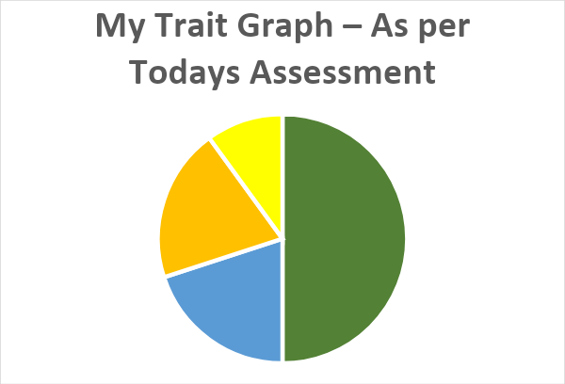
Personality Assessment for _______________________
My Preferences:
I scored high in the Green colour which at first confused me because my sisters were valedictorians, not me. However, as I read about the traits of this personality type I did see myself in it. I eventually realized that I was inquisitive, and very curious but I was not strongly academic, which means I love learning and experimenting and researching but I never scored at the very top of my academic classes.

My Personality Traits: I do like to explore and perfect concepts and work independently, which are quintessentially green characteristics. I also am drawn to competency as a personal and career goal. Blue is a powerful trait group for me as I find myself valuing authenticity in people even over more admirable traits and I see relationships as particularly valuable.

I realized that I enjoy theory and exploring new thoughts, I enjoy exploring new work rather than routine work and enjoy discovering results rather than knowing results before I start a project. I also like to work in concepts such as,” how important freedom of the press is,” rather than selling shares in a newspaper business, although there are aspects of business that attract me.

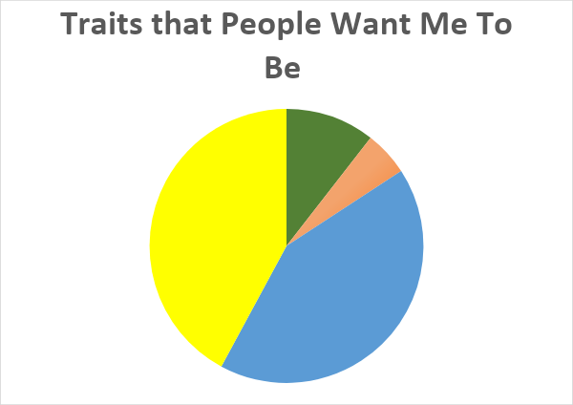

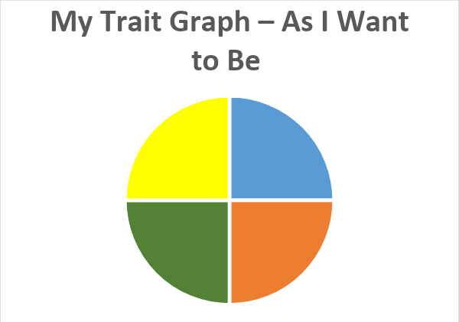

The Me Poster: Your Interests, Skills, Values and Traits should point to some occupations. If you look at Joe Sample below you will notice many of his interests are theory things and he was interested in occupations that deal with theory. His skills show a lot of independence and communication so it seems natural he would like teacher, preaching and instruction because they are related to communication and theory, and he did. Look at your skills this way and we can spend a few minutes brainstorming for occupations that might fit you.

My Preferred Skills
• Listening Skills Time Management
• Verbal Communication Negotiating
• Written Communication Independence
• Initiative Researching information
• Instructing with Clarity Dealing with Stress
My Interests
• Nature Investing and financial mgmt.
• The Meaning of Life • Writing and Reading
Journalism
• Exploring other cultures Public Speaking
• Cooking Healthy Living
Helping People
• Teaching
• Canoeing and Camping Parenting

My Research

Reporter
Broadcasting
Psychologist
Counsellor
Politician
Travel Guide
Preacher
Teacher
Author
HR Officer
Adult Education
Professor
Labour Leader

What am I working for?

Most Important: Use my Talents
Second: Value what I do for a living
Third: Profit —earn a comfortable living

Personal Profile for Joe Sample
On March 17, 2019

My Values
• Being Helpful Honesty
• Providing for family Being Competent
• Getting Healthy Being Creative
• Peace Adventure
• Ethical Leadership Outdoor Adventure
• Fairness
Personality Traits
• Authentic Logical
• Peaceful Love to Learn
• Honest Big Picture Thinker
• Helpful Inquisitive
• Planning Seek Beauty

My Top Skills
My Top Interests

My Occupation Ideas or fields of work I would like to look at.

MY BASIC MOTIVATION?

My Satisfying Traits from True Colours

My Top Values

ALIS Assessment

The ALIS assessments will help add occupations to your research list – we will focus on the interest assessment but you can go back and do as many assessments as you like.
- Go to alis.alberta.ca
  - Click on:
Plan Your Career, Career Insite on the quick links (right side), Know Yourself, Interest Exercise.
OR Sign Up
    - Occ Info Demo - Following the interest exercise you should get a list of occupations with some Labour Market Information.

Neat Idea

Another great assessment can be found from the State of Minnesota career center. Find the link on our instructors’ site.

Section B achieve what you want

The Basics of achieving what you want

- Get the Data
  - What do I need to do this work?
  - What helps me get into this field?
  - What could stop my progress?

- Understand your motivation

About Getting Data
Use ALIS, College Tours and Career Connections to Get Data:
There are many things to learn about each occupation and not everyone will agree on what is good and what is not-so-good about a job. I once heard one of my co-workers talking about how bad our job was and everything he disliked qualified as okay from my point of view. It became obvious to me that we had completely different opinions about what made a job a “good job”.

Using Fields of Work not Jobs
If you look at Joe Sample you see that he is keen on teaching and journalism and he put related occupations in his research pile. But it would be good to think bigger than that. When he goes to ALIS to do some research he does not type in Journalist but goes under “Field of Study” and clicks communication where he finds the occupations he was thinking of but he also finds Cartoonist which he really likes. So, don’t rush – take some time to look for really good ideas.

Data is better than Scuttlebutt
I hear scuttlebutt all the time. I remember a parent advising their student to avoid policing because they do not make any money, when in fact policeman are well paid and have one of the best pension plans in Canada. Another uncle told his niece that there are no jobs in Biochemistry so she should study something real. It did not take much research to find out that uncle was referencing the wrong generation of data. This off-the-cuff-unresearched information is not data, it is scuttlebutt and it can be misleading. There is better wisdom in getting your information from a more reliable source.

alis.alberta.ca (demo with labour market info)

DATA EXERCISE 1: Do Some Explorative Research?

Find 5 occupations you think might be interesting for you under 2 different Industries

Industry _______________________ Industry _______________________
1. ____________________________ ` 1. ____________________________
2. ____________________________ 2. ____________________________
3. ____________________________ 3. ____________________________
4. ____________________________ 4. ____________________________
5. ____________________________ 5. ____________________________

Find 5 occupations you think might be interesting for you under 2 different Fields of Study or Favorite Subject

Field __________________________ Field __________________________
1. ____________________________ ` 1. ____________________________
2. ____________________________ 2. ____________________________
3. ____________________________ 3. ____________________________
4. ____________________________ 4. ____________________________
5. ____________________________ 5. ____________________________

DATA EXERCISE 2: Do Some Comparison Research?
Pick two of your favorite occupations and compare them with the hopes of finding which one is a better fit for you.

Thought | Occupation 1 | Occupation 2
Name of occupation

What do workers in this occupation do? What are their tasks.

Name some specific skills workers need to do this occupation.

Name some Transferable Skills that are key to do well in this occupation.

Thought | Occupation 1 | Occupation 2
Name of occupation

What training, education or certification do you need to do this work?

How comfortable would you be in this work environment? (think of the people, location, sights, smells and atmosphere).

How happy would you be with the work schedule? Do you need to do shift work, overtime, split shifts? Do the hours of work fit with your strengths?

Would you rate the wage or salary as not good, good, okay or great?

How does the employment outlook look?

Is this an occupation where you will have a chance for promotion, raises or will it lead to different occupations in the future?

Do you have other questions?

MOTIVATION EXERCISE 1: What motivates you?

Next let’s think about what will satisfy you. You will be working for more than a few years and likely putting in some long hours here and there. What makes you want to do that?
Activities and
Talents

Independence, Learning, Personal Progress,
Power
Prestige
Profit
Activities and
Talents

To Value or
Be Valued

Promotions, Renumeration (pay), Authority, Recognition, Status, Competition, Winning,

Being Part of a Team
Helping People,
Being Useful or Needed,
To Grow Spiritually

Other Ideas
Be a Father
Be a Mother
Follow Adventure
Fear of Failure

MOTIVATION EXERCISE 2: Record Your Motivation
Use the Motivation section of your poster, or your bullet journal to record the most important motivations for you to work.
SECTION C - Create a Plan

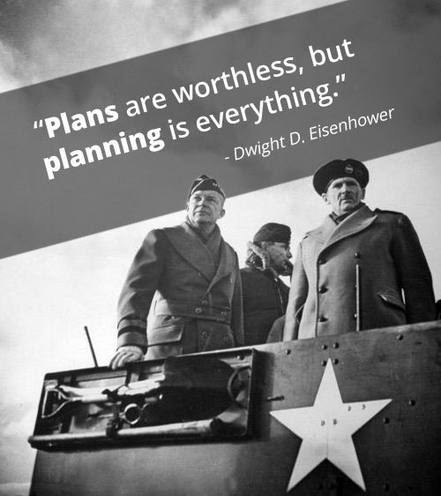

Planning Exercise 3: Real Life Planning
- Use the next two pages to try out a bit of planning and see if you can find a way to plan AND live in the moment. Also see if you can find items to do in the present that will help you with your future goals.
2 The Goals
5 Year Plan

Daily Goals

Life Goals
Career:
______________________________________________________

Bucket List
______________________________________________________

Financial
______________________________________________________

Family or Social
________________________________________________________________________

Personal
______________________________________________________

Career:
______________________________________________________

Bucket List
______________________________________________________

Financial
______________________________________________________

Family or Social
________________________________________________________________________

Personal
______________________________________________________

Career:
______________________________________________________

Bucket List
______________________________________________________

Financial
______________________________________________________

Family or Social
________________________________________________________________________

Personal
______________________________________________________

The Career Plan - Here is one idea on how to build a career plan
Step 1 – Identify the Position or Occupation You would like to be in

What Skills, Abilities or Experience should you acquire to make you successful in this position?

What Skills, Abilities or Experience do you have that match well with this position?

What is attractive about this position?

Step 2 – Identify Next Jobs That Will Lead You to Your Preferred Position

What Skills, Abilities or Experience do you have that match well with this position?

Of the Jobs or Training that are applicable which is the most likely to work out for you?

What Training or Jobs will help you fit this opportunity?

Step 3 – Draw out a Likely Sequence of Milestones and Your Tasks

Milestone 1 -
Milestone 3 -
Milestone 2 -

Tasks:

Tasks:

Tasks:

SECTION D – STAYING ON TRACK

STAYING ON TRACK EXERCISE 1: The 6 List Story

Efficiency experts sell the secret of obtaining an edge to company owners or executives. The story is told of an expert who just could not sell his service to a company’s Chief Executive Officer. Finally, the CEO said, “If you could find a simple procedure to make everyone in my organization do their job and achieve their goals, well I would pay for that.”

The expert said “I can do that.” He ended up having every executive in the organization complete a 6 List every day. The plan being:
- Identify the 6 key actions you can take that would help you achieve your goal
- Prioritize them with number 1 being the most important
- Write all 6 items down and the entire package must be doable in one day
- First thing in the morning start with number one
- When number one is done move on to number two until you have completed all six – do nothing else until all 6 are done or transferred
- At the end of the day sit down and write a 6 List for tomorrow

Often we have great goals or plans but fail to follow up with the actions necessary to make things happen. The 6 List can help you retain some focus in a world with many distractions.

The experts name was Ivy Lee and the CEO was Charles Schwab of Bethlehem Steel and the meeting occurred in the early 1900’s. This same procedure is taught in many business schools today.
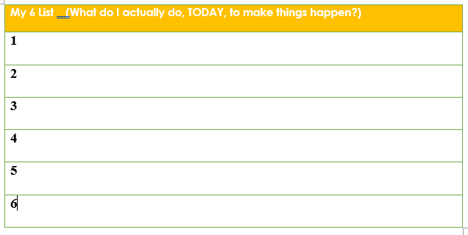
Planning is bringing the future into the present so that you can do something about it now. Alan Lakein
Read more at https://www.brainyquote.com

“If the world were merely seductive, that would be easy. If it were merely challenging, that would be no problem. But I arise in the morning torn between a desire to improve the world and a desire to enjoy the world. This makes it hard to plan the day.”
― E.B.

Thoughtful financial planning can easily take a backseat to daily life. Suze Orman
Read more at https://www.brainyquote.com

“Life is what happens to us while we are making other plans.”
― Allen Saunders

“A good traveler has no fixed plans and is not intent on arriving.”
― Lao Tzu

Quotes
STAYING ON TRACK EXERCISE 2: Barriers
What happens if you have found an occupation that you really like but it does not seem practical to you. You may have decided you like to work with automobiles but it is very hard to get a job as a mechanic. You know this because you have tried and you did not get even a single interview. Does that mean you are stuck? That you cannot move on?

Identify why you want to be a ________________________________:
Why?

What are the barriers stopping you?

Do you have any resources to help you figure out how to get around the barriers or to help figure this out? List them.

In our example the potential mechanic found a college course that trained him to get a job as a mechanic. However, he did not have his high school diploma and thought he would never get in. As it turns out, and after getting some information (read DATA) from the college, he found out you do not need a high school diploma but what he needed to do was commit the time and money for a year of college. After examining the costs and the potential payoff he went for it.

Extra – Do Not Print
1 The Nature of Plans

Let’s ask
Mike
You should get good at planning if you want to do well in your career. You should be able to see a way to progress and that will help you be motivated. But just seeing a way is not enough you need to take action and that is hard to do if you do not have a plan, at least it is hard to do well. Finally, if you have a plan you can anticipate some of the barriers and problems and have a solution worked out before you actually encounter the problem. This is powerful as you can move forward and be confident that you can achieve what you want because you can see the future clearly.

Mel
I think if you want to enjoy life that you should take it as it comes and just enjoy each experience and each day just because you have that day, the present is a gift. People obsessed with planning are so busy living in the future that they can never enjoy today. Success for me is enjoying each day and thus my life and I do not need to plan that, I just need to be present and notice the good things.

Planning Exercise 1: The Debate
This Photo by Unknown Author is licensed under CC BY
Which of these advisors is correct? Split into two teams and organize a debate to help us identify the wisest counsellor.

The Strengths of Mike’s ideas | The strengths of Mel’s ideas
The weakness of Mike’s ideas | The weakness of Mel’s ideas
Planning Exercise 2: What Works for You

Using this space or your bullet journal figure out how planning and strategizing fits into your career.
- Do you want to relax and watch the world go by or do you want to plan and prepare for the future?
- What if you want to do both? How would that work if you planned but also tried to live each day for the present and enjoyed what each day has to bring you?

Do I want to lead a planned life?
Do I want to accept each day as it is, without planning and strategizing what I want?
Brainstorm ways to manage a life that allows you to plan your achievements but also allows you to take each day for the joy it brings.

